Sprint 2 – Requirements and Design
BookMyCut – Salon Appointment & Customer Manager

1. Introduction

This report provides the deliverables of the Sprint 2 of BookMyCut web application. This sprint has the purpose of specifying a complete list of user requirements in the form of user stories, and designing the first components of the application, such as personas and scenarios, a use case model, wireframes, and user flows. BookMyCut is a customer, staff, service, and appointment CRUD app of a small hair and beauty salon developed using Node.js, Express.js, Pug, and MySQL and version managed with Git.

2. User Stories

These are the functional requirements of the first version of BookMyCut, which are specified as the following user stories. They are provided as the owner of the salon and its employees are the primary users of the system. These user stories are also put and monitored on the team task board with the corresponding labels and priorities.

1. As a salon owner, I wish to gain access to the system safely to ensure only the authorised employees have access to the system to manipulate the appointment and customer information.

2. Being a staff member, I would like to be able to view a dashboard with the appointments of this day in order to have a quick glimpse of who comes, and at what time.

3. As an employee, I wish to see the list of the entire number of appointments on a particular date because I will be able to arrange the work on a specific day.

4. As an employee, I desire to make a new appointment by selecting a customer, a service, a member of staff, date and time in order to be able to book the clients in a short period of time when they are on the phone or at the desk.

5. This is because as a member of staff, I would like to make edits on the date, time, staff member or service of an already booked appointment in order to make changes to bookings in case of a change of plans by customers.

6. Being a staff member, I would wish to cancel an appointment and document the reason behind that cancellation so that the schedule might reflect the presence of the person and I could later make an analysis on cancellations.

7. Being an employee, I would like to see a list of all customers to be able to find and manipulate client information as fast as possible.

8. Being a member of the staff, I would like to add a new customer record with name, phone number, email, and notes because I want all customer contact details and preferences to be stored in a single location.

9. As an employee, I would like to update the contacts of a customer to ensure that I maintain their contact information.

10. As a staff, I would like to delete a customer record where the customer is not required any longer and which does not contain any essential records to the customer to ensure that the customer list is not cluttered.

11. As an employee, I would like to be able to find customers either by their name or phone number/ email so that I can easily get people when conversing.

12. Being a salon owner, I wish to have a list of services with their respective durations and costs so that I can see what the salon offers in a single place.

13. As a salon owner, I would like to introduce new services with a name, description, time period, and price to renew the services offered by the salon.

14. As a salon owner, I would like to make amendments to the existing services so that prices, duration, or description can be changed where necessary.

15. As an owner of the salon, I wish to leave a service inactive instead of drop it in order to maintain the record of the appointments without clearing the active list.

16. I would like to see a list of the staff members, who can offer services to us as a salon owner so that I could manage the information about the team in the system.

17. As a salon owner, I would like to add and modify staff records, such as their name, position, and working status, according to which the system will show who is actually working in the salon.

18. As a salon owner, I would wish to have a set time to ascertain the number of appointments completed by each staff member in order to be able to know the workload and performance.

19. As the owner of a salon, I would like to see what services have the highest number of bookings within a specific date period in order to be able to make proper decisions of promotion and pricing.

20. Being a salon owner, I would like to know on which days and which times the salon is the busiest in order to better plan staffing.

21. Being an owner of a salon, I would like to know the number of canceled and missed appointments over time so that I can know how much money I could lose and introduce changes in policies.

22. Being a member of staff, I would like to access the history of his/her appointments to know what that particular customer typically orders and present them with a more personalized service.

23. Being a staff member, I would like to be able to filter appointments based on the staff member to view only my schedule or the schedule of a colleague.

24. As an employee, I would prefer that the system authenticate date and time entries to ensure that I would not make appointments in the past or even make overlapping appointments to the same employee and time slot.

3. User Stories and Task Board Tracking

Each of the above user stories are placed on the team task board and labelled with the respective epic or category (Appointments, Customers, Services, Staff, Reporting, Authentication). The user stories receive a priority and are assigned to a sprint. The stories are displayed as columns, Backlog, To Do, In Progress, In Review and Done to the board that will be utilized in monitoring progress throughout the development process.

4. Personas and Scenarios
Persona 1 – Salon Owner
Name: Kabir
Age: 36
Role: Salon owner and senior stylist.
It is the duty of the owner to supply services as well as to run the business. They are used to daily web-based tools and would like to have the most obvious picture of the appointments, staff workload, and demand in the services.
Scenario: On entering the BookMyCut, the owner sign-in and opens the dashboard at the beginning of the day. The information on the dashboard includes the appointees in a table on the current day based on the staff and the time. The owner realizes that one stylist is busy at the end of the day and another one has no assignments. The owner also uses the appointment edit feature in order to redistribute some of the appointments to even out the workload. Then the owner benefits later when he uses the reporting section to view the most popular services in the previous month and realises that colour services are rising. This can assist in making personnel and inventory decisions.
Persona 2 – Regular Customer
Name: Simon
Age: 26
Role: Office worker and regular client
The customer works in a busy job and normally visits the salon at the end of the working day. They desire fast and efficient booking and confirming and have the staff to recall their customary preferences.
Scenario: The customer calls the salon and book a haircut following the work. An employee clicks BookMyCut, types in the name of the customer and accesses his information and appointment history. The employee clicks on the appointment creation form and types in the customer, the type of service he or she wants, which is Cut and blow dry, his or her favorite stylist, and a date and time that is at his disposal. The system authenticates the slot selected to avoid any possibility of a double-booking. After a reservation is made, it will be displayed on the day-to-day appointment list of that stylist. The stylist is able to open the system on the day of the appointment and see the name of the customer and the service provided and be prepared to meet them at the day of the appointment.

5. Use Case Model
A use case diagram and descriptions of the key use cases describe the use case model of BookMyCut.
Actors:
Salon Owner
Staff Member
Authentication System
The key users are Log In, Dashboard, Customer Management, Staff Management, Service Management, Appointment Management, and Report Viewing. The staff member and the Salon Owner actors in the use case diagram are related to the use case of Log In. After confirmation, the Staff Member actor is linked to View Dashboard, Manage Customers, Manage Appointments, and, in some cases, Manage Services. The Salon Owner actor is linked to the entire key uses cases such as Manage Staff and View Reports. The Manage Customers use case generalises the operations to add, read, modify and delete customer records. Equally, the Manage Services, Manage Staff and Manage Appointments all represent CRUD operations on those entities respectively. View Reports deals with the observation of the popularity of services, the workload of the staff, and the statistics of appointments during the selected time frame.
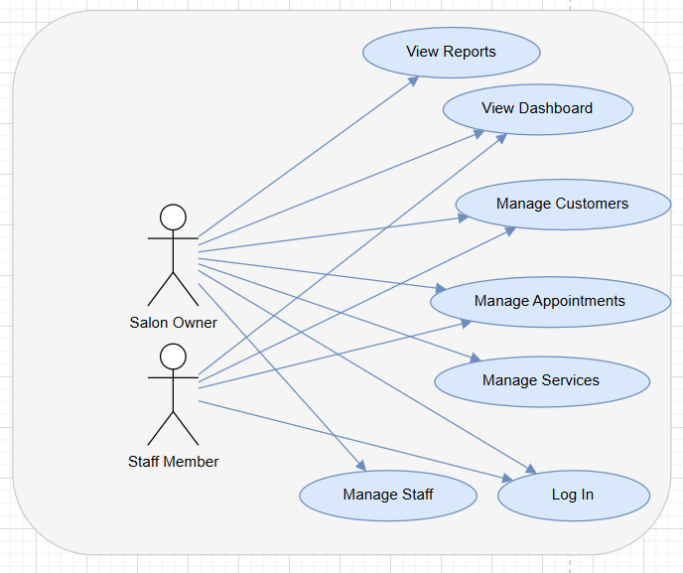

6. Wireframes
The wireframes give the design and content of the major screens of the application. They are developed in the same design with Pug templates and with a similar header and navigation bar.
In the case of the Login page, there is a simple form and it is centered with screen and two input fields one with the username and the other one with the password and a login button. The top part of the form has the name of the application BookMyCut. In case of failure to make a login, the error message will be displayed below the form.
The Dashboard page includes a welcome message and a summary of the appointments of the day. There is a horizontal navigation bar on the top that has a link to Dashboard, Appointments, Customers, Services, Staff and Reports as well as a logout link. The major area has a table where the list of the appointments of the day is displayed, and the columns include time, customer name, service, staff member, and status. A date picker enables one to change to a different day.
The page of Appointments list has a heading of appointments and a date filter. Under the heading, there exists a button to make the new appointment. The primary section is a table which has columns of date, time, customer, service, staff and actions. On the actions column, it is possible to edit or cancel each appointment.
Appointment form page is employed in creation and editing of an appointment. It includes customer selection, service, employee, date, time and optional notes. There are save and cancel buttons at the bottom.

The Customers list page will have a search bar on the top where the staff will insert a name, phone number, or email and a button to add a new customer. The table provided below contains columns of name, phone, email and actions.
The Customer form page includes the name field, phone field, email field, and notes field concerning preferences or special instructions. Existing data is entered into the form when editing a customer.
The Services list page displays the list of available services according to their names, duration, cost, and availability with a button to add new services. The form page will enable the owner to update or add such details and determine whether the service is active.
On the page of the Staff list, the names of every staff member, position and state are displayed, as well as there is a button to create new staff. Form page allows the owner of a salon to add or update the staff information and indicate whether they are working in the salon at the moment.
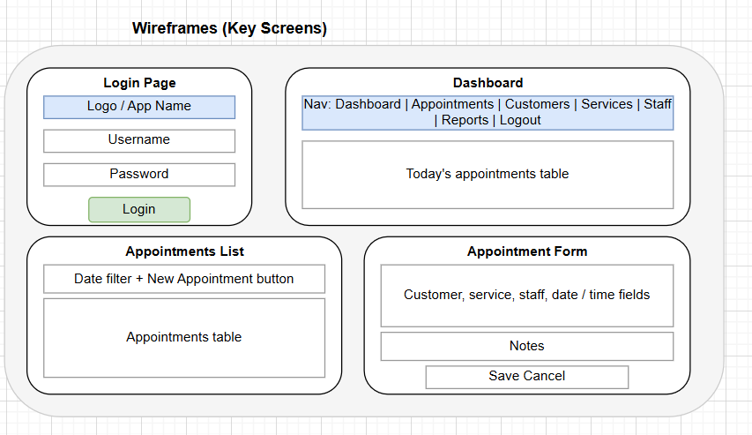

7. User Flow Diagrams
The user flows are step by step descriptions of the way the users navigate the system to perform important tasks.
Flow 1: The process of booking a new appointment. One of the staff members clicks on the application and gains access to it. Their menu selection is Appointments. On the appointments page where they decide to make a new appointment. The appointment form is opened in the system. The staff member will pick a customer that is already in a list or a search box and proceeds to pick a service, pick a staff member to do a service and pick a date and time. The system will ensure that the time slot selected is a legitimate one that is not occupied by the same staff member. In case of a valid form, the personnel would save it, store the appointment in the database, and the system would redirect to the appointments list where the new appointment is listed.
Flow 2: Cancelling or making an appointment. One of the staff members logs in and visits the appointments page. They narrow down by date where needed and find the appointment that they need to alter. They decide to edit the appointment and the appointment form is opened and it is filled with existing data. They edit the hours or employee and make the changes. The system authenticates the new information and changes the record in the database. In case the customer wishes to cancel the appointment rather, the staff member selects the cancel button. The system will require confirmation and an optional-reason. The design choice is either to cancel or remove the appointment after confirmation and an update to the appointments list takes place.
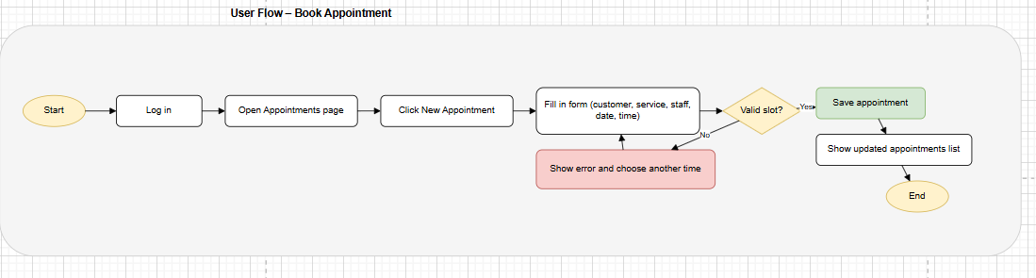
Flow 3: Dealing with customer records. One of the personnel enters and chooses Customers in the navigation bar. On the customers page they will put in the search bar and search by the name of a customer or phone number. In the event that the customer is present, on their row selection they display information or open the edit form to edit the contact details. In case of a new customer, the member of staff will decide to do a new customer and complete the form. Saving takes the new record and stores it in the database and it goes back to the customer list.
Flow 4: Receiving reports as the owner of the salon. The owner clicks to log in, and then he or she selects the menu item Reports on the navigation bar. They select a date range. The system will query the database and provide summary details like the number of appointments made by the staff members, the most booked services and the summary of the appointments made per day of the week. The owner is able to change the range of dates to view various periods.

8. Optional Activity and Sequence Diagrams
The booking of an appointment will start with an activity diagram that starts with the staff member initiating the process of booking an appointment on the appointments page. The subsequent step is to open the appointment form and then choose a customer, service, a member of staff, and a date and time. A decision node will test the availability of the time slot. When not available, the flow goes back to the selection of date and time showing an error message. In case it exists, the form is submitted by the staff member. Another decision is the validity of input. Otherwise, the flow will go back to filling the form with validation messages. In case of a proper validation, the system stores the appointment to the database and displays confirmation and updated list of appointment.
Activity Diagram

Sequence Diagram

The staff member, browser, web application, appointment controller, appointment model and database are the components of a sequence diagram involved in the creation of an appointment. The employee clicks with the browser to get the new appointment form. An HTTP request is sent to the web application by the browser which is redirected to the appointment controller. The controller extracts the required data on the appointment model and this makes queries to the database and retrieves the results. This data is sent to Pug template by the controller and the form is shown by the browser. Upon submitting the form by the member of the staff, the browser makes a second HTTP request containing the form data. The appointment controller confirms the data, and then calls the appointment model to add a new record to the database, whereby it is confirmed and then responds by telling the browser to show the updated appointments list.

